LEADERS ARE NOT BORN. THEY ARE MADE.
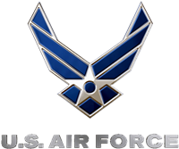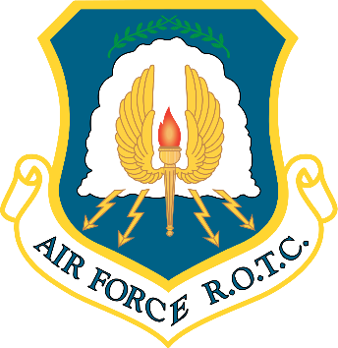

JOIN US FOR OUR SPRING OPEN HOUSE
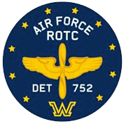
Air Force ROTC, Det 752
Wilkes University
169 S. Main St., Wilkes Barre, PA 18701
April 11th, 3:00PM - 6:00PM
- Participate in information sessions/military training
- Parents and family are welcome
- Speak with current Air Force Officers and ROTC cadets
- Learn about benefits, scholarships, and exciting career opportunities
- Create bonds with new people that will last a lifetime
- Gain and enhance leadership skills and abilities
- For students interested in attending Wilkes University, Bloomsburg University, East Stroudsburg University, King's College, Marywood University, University of Scranton, Penn State University (Hazleton, Scranton, Schuylkill, Wilkes Barre), and Luzerne County Community College

Email: rotcdl@wilkes.edu | Phone: 570-408-4860 | Web: https://wilkes.edu/rotc

